Arrays

The Array object, as with arrays in other programming languages, enables storing a collection of multiple items under a single variable name, and has members for performing common array operations.

**Description**

In JavaScript, arrays aren't primitives but are instead Array objects with the following core characteristics:

JavaScript arrays are resizable and can contain a mix of different data types. (When those characteristics are undesirable, use typed arrays instead.)

JavaScript arrays are not associative arrays and so, array elements cannot be accessed using arbitrary strings as indexes, but must be accessed using nonnegative integers (or their respective string form) as indexes.

JavaScript arrays are zero-indexed: the first element of an array is at index 0, the second is at index 1, and so on — and the last element is at the value of the array's length property minus 1.

JavaScript array-copy operations create shallow copies. (All standard built-in copy operations with any JavaScript objects create shallow copies, rather than deep copies).

Shallow Copy vs Deep Copy

In JavaScript, there are two ways to copy objects: shallow copy and deep copy. Shallow copying creates a new object with references to the same memory locations as the original object, while deep copying creates a new object with new memory locations for all of its properties and nested objects or arrays.

**Array indices**

Array objects cannot use arbitrary strings as element indexes (as in an associative array) but must use nonnegative integers (or their respective string form). Setting or accessing via non-integers will not set or retrieve an element from the array list itself, but will set or access a variable associated with that array's object property collection. The array's object properties and list of array elements are separate, and the array's traversal and mutation operations cannot be applied to these named properties.

**Syntax**:

Array literal notation

Arrays can be created using the literal notation:

JS

const fruits = ["Apple", "Banana"];

console.log(fruits.length); // 2

console.log(fruits[0]); // "Apple"

Array constructor with a single parameter

Arrays can be created using a constructor with a single number parameter. An array is created with its length property set to that number, and the array elements are empty slots.

JS

const arrayEmpty = new Array(2);

console.log(arrayEmpty.length); // 2

console.log(arrayEmpty[0]); // undefined; actually, it is an empty slot

console.log(0 in arrayEmpty); // false

console.log(1 in arrayEmpty); // false

**Array() constructor**

The Array() constructor creates Array objects.

JS

new Array()

new Array(element0)

new Array(element0, element1)

new Array(element0, element1, /* … ,*/ elementN)

new Array(arrayLength)

Array()

Array(element0)

Array(element0, element1)

Array(element0, element1, /* … ,*/ elementN)

Array(arrayLength)

**Important Methods**

### [JavaScript Array length](https://www.programiz.com/javascript/library/array/length)

Returns the number of elements in an array

### [JavaScript Array reverse()](https://www.programiz.com/javascript/library/array/reverse)

Returns the array in reverse order

### [JavaScript Array sort()](https://www.programiz.com/javascript/library/array/sort)

Sorts the elements of an array in specific order

### [JavaScript Array fill()](https://www.programiz.com/javascript/library/array/fill)

Returns array by filling elements with given value

### [Javascript Array join()](https://www.programiz.com/javascript/library/array/join)

Concatenates the array elements to a string

### [Javascript Array toString()](https://www.programiz.com/javascript/library/array/tostring)

Returns the string representation of an array

### [JavaScript Array pop()](https://www.programiz.com/javascript/library/array/pop)

Removes and returns the last array element

### [JavaScript Array shift()](https://www.programiz.com/javascript/library/array/shift)

Removes and returns the first array element

### [JavaScript Array push()](https://www.programiz.com/javascript/library/array/push)

Adds elements to end of array & returns its length

### [JavaScript Array unshift()](https://www.programiz.com/javascript/library/array/unshift)

Adds elements to start of array and returns length

### [JavaScript Array concat()](https://www.programiz.com/javascript/library/array/concat)

Returns array by merging given value and/or arrays

### [JavaScript Array splice()](https://www.programiz.com/javascript/library/array/splice)

Returns an array by changing its elements in place

### [JavaScript Array lastIndexOf()](https://www.programiz.com/javascript/library/array/lastindexof)

Returns the last index of occurrence of an element

### [JavaScript Array indexOf()](https://www.programiz.com/javascript/library/array/indexof)

Returns the first index of occurrence of element

### [JavaScript Array of() Method](https://www.programiz.com/javascript/library/array/of)

Creates a new Array instance from given arguments

### [JavaScript Array slice()](https://www.programiz.com/javascript/library/array/slice)

Returns a shallow copy of a portion of an array

### [JavaScript Array findIndex()](https://www.programiz.com/javascript/library/array/findindex)

Returns index of element that satisfies condition

### [JavaScript Array find()](https://www.programiz.com/javascript/library/array/find)

Returns first element that satisfies a condition

### [JavaScript Array includes()](https://www.programiz.com/javascript/library/array/includes)

Checks if a value exists in an array

### [Javascript Array reduceRight()](https://www.programiz.com/javascript/library/array/reduceright)

Reduces array to single value from right to left

### [Javascript Array reduce()](https://www.programiz.com/javascript/library/array/reduce)

Reduces array to single value from left to right

### [Javascript Array isArray()](https://www.programiz.com/javascript/library/array/isarray)

Checks if the given value is a JavaScript Array

### [Javascript Array filter()](https://www.programiz.com/javascript/library/array/filter)

Returns array by filtering elements on given test

### [JavaScript Array map()](https://www.programiz.com/javascript/library/array/map)

Returns array by mapping elements using given func

### [Javascript Array forEach()](https://www.programiz.com/javascript/library/array/foreach)

Executes the given function on array elements

### [Javascript Array some()](https://www.programiz.com/javascript/library/array/some)

Tests if any element passes given test function

### [JavaScript Array.every()](https://www.programiz.com/javascript/library/array/every)

Tests if all elements pass the given test function

### [Javascript Array entries()](https://www.programiz.com/javascript/library/array/entries)

Returns iterator containing key/value pair array

### [JavaScript Array keys()](https://www.programiz.com/javascript/library/array/keys)

Returns an iterator containing keys of array items

### [JavaScript Array values()](https://www.programiz.com/javascript/library/array/values)

Returns iterator containing values of array items

### [Javascript Array.from()](https://www.programiz.com/javascript/library/array/from)

Creates a new Array from array-like object

### [Javascript Array constructor](https://www.programiz.com/javascript/library/array/constructor)

Returns the constructor function for the array

### [Javascript Array copyWithin()](https://www.programiz.com/javascript/library/array/copywithin)

Copies and overwrites elements within the array

### [JavaScript Array.toLocaleString()](https://www.programiz.com/javascript/library/array/tolocalestring)

Returns string representing the elements of array

### [JavaScript Array flat()](https://www.programiz.com/javascript/library/array/flat)

Flattens the nested array to given depth

### [JavaScript Array flatMap()](https://www.programiz.com/javascript/library/array/flatmap)

Returns new array by mapping and flattening array

Slice method

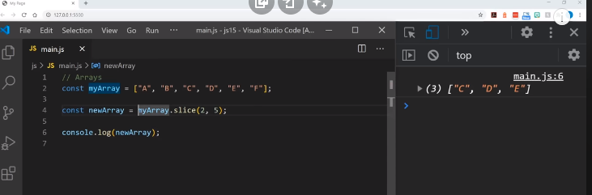

Spread operator

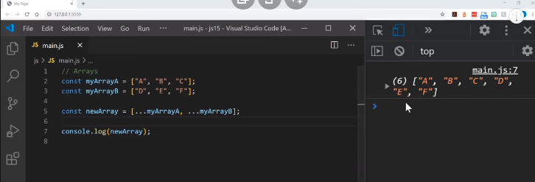

Multi-dimensional array or nested array:

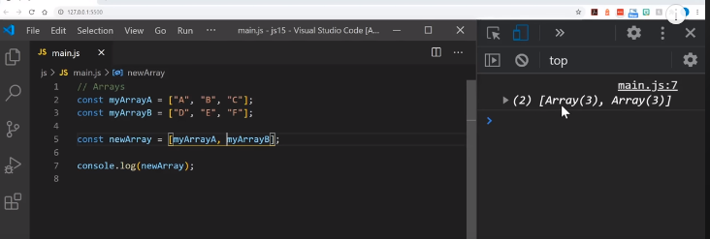

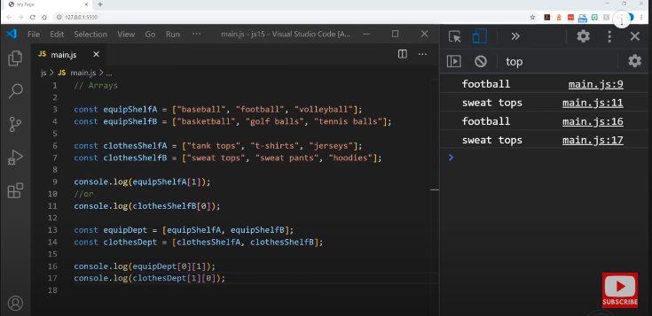

All Method: <https://developer.mozilla.org/en-US/docs/Web/JavaScript/Reference/Global_Objects/Array/@@iterator>

From MDN Page